

SENIORCARE INC.

AREA PLAN ON AGING

Federal Fiscal Years 2026-2029
Main Office:
49 Blackburn Center
Gloucester, MA 01930
Satellite Office:
100 Cummings Center, Suite 130G
Beverly, MA 01930
866-927-1050 (Toll Free)
MassRelay: 711 or (800) 439-2370 (TTY/ASCII)
www.Seniorcareinc.org

Table of Contents
Planning and Service Area Map 3
Executive Summary 4
Area Agency on Aging 4
Aging Services Access Point 6
Context 7
Needs Assessment Summary 8
Top Ten Reported Needs 8
Focus Area Coordination 9
Goal 1: Older Americans Act Core Programs 9
Goal 2: Greatest Economic Need and Greatest Social Need: 14
Goal 3: Expanding Access to Home- and Community-Based Services (HCBS) 15
Goal 4: Caregiving 15
Performance Measures 16

SeniorCare Inc.
Area Agency on Aging/Aging Services Access Point
www.seniorcareinc.org

49 Blackburn Center
Gloucester, MA 01930
978-281-1750 or 866-927-1050
FAX: 978-281-1753
Cummings Center, Suite 130-G
Beverly, MA 01915
MassRelay: 711 or (800) 439-2370 (TTY/ASCII)
FAX: 978-969-0358

Planning and Service Area Map
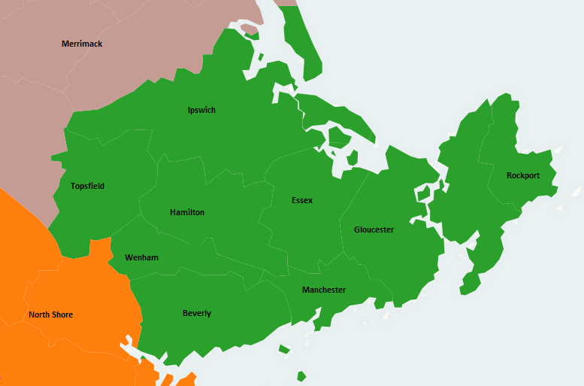
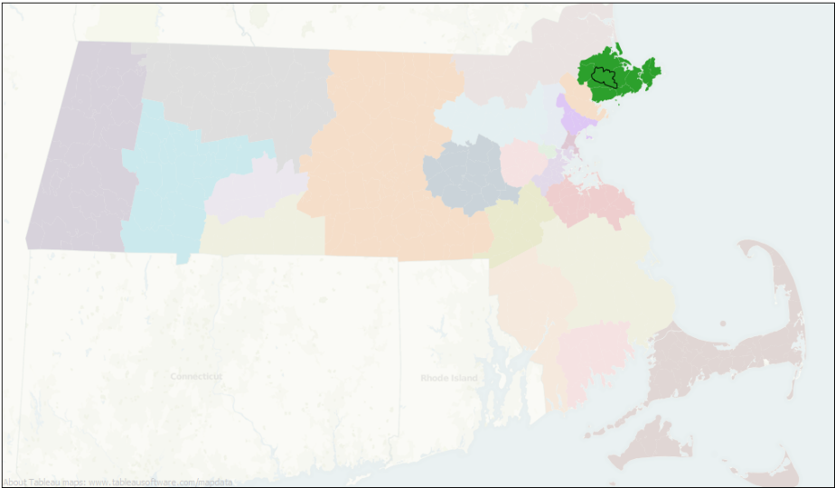
Providing Support and Services to Older Adults in Beverly, Essex, Gloucester, Hamilton, Ipswich, Manchester-by-the-Sea, Rockport, Topsfield, and Wenham
SeniorCare Mission Statement
SeniorCare is a consumer centered organization that provides and coordinates services to elders and others who need assistance to enable them to live independently at home or in a setting of their choice while remaining part of their community.

Executive Summary
For more than 53 years, SeniorCare Inc. (SeniorCare) has been a trusted community leader, providing and coordinating a comprehensive array of programs and services for adults age 60 and over, individuals with disabilities, and family caregivers residing in the North Shore and Cape Ann communities of Beverly, Essex, Gloucester, Hamilton, Ipswich, Manchester-by-the-Sea, Rockport, Topsfield, and Wenham. An innovative and multi-faceted private nonprofit organization, SeniorCare serves as both a federally designated Area Agency on Aging (AAA) and a Massachusetts-designated Aging Services Access Point (ASAP). SeniorCare is also a state-designated Adult Protective Services agency responsible for investigating and addressing reports of elder abuse, neglect, self-neglect, and financial exploitation.
SeniorCare’s core values—community, choice, independence, respect, and compassion—guide every aspect of our work. Through a person-directed approach, SeniorCare responds to the diverse and evolving needs of older adults while honoring individual choice and autonomy, supporting the ability of people to live independently with dignity, purpose, and meaning in the community of their choice. We value our skilled and dedicated staff and volunteers, who lead with respect and compassion. SeniorCare is committed to delivering culturally responsive services, honoring diversity, continually educating ourselves about the needs of those we serve, and intentionally incorporating consumer perspectives into organizational planning and activities.
SeniorCare takes an active role in educating older adults, care partners, and community stakeholders about available services and supports. Recognizing that aging is dynamic and that individual needs change over time, we routinely engage with older adults, family caregivers, people with disabilities, and community partners to ensure they are informed of available options. In addition to serving as a trusted conduit to services, SeniorCare also advocates for and raises awareness of the needs of older adults and caregivers, working collaboratively with community organizations and partners to address and articulate those needs.

Area Agency on Aging
Area Agencies on Aging were established through the federal Older Americans Act (OAA), which was originally passed in 1965 and most recently reauthorized under the Supporting Older Americans Act of 2020. The OAA remains the primary federal legislation authorizing programs and services that provide critical support to older adults and their caregivers. The Administration for Community Living (ACL), within the U.S. Department of Health and Human Services, currently administers most OAA programs nationally.
As an Area Agency on Aging, SeniorCare receives federal funding administered by the State Unit on Aging—the Massachusetts Executive Office of Aging & Independence (AGE)—to plan for, develop, implement, and monitor a comprehensive range of supportive and nutrition services at the regional level. Programs and services that target older adults in greatest economic need and older adults in greatest social need are a priority.
OAA funding supports a range of vital, community-based services designed to promote the independence and well-being of older adults. OAA funding is provided for:
- Title IIIB – Legal Services, Supportive Services, including in-home and community-based services, Access Services - services such as transportation designed to help individuals access other services.
- Title IIIC – Nutrition Services including home delivered meals, congregate meals, nutrition education, and nutrition counseling
- Title IIID – Evidence-Based Disease Prevention and Health Promotion services.
- Title IIIE- Family Caregiver Support Program
- Title VII - LTC Ombudsman and Elder Rights/Protective Service Programs
SeniorCare utilizes OAA funding to support a comprehensive range of programs, including Information and Referral services, Benefits Specialist support, Family Caregiver Support, Home Delivered Meals and Congregate Dining, Volunteer Medical Transportation, Volunteer Friendly Caller, In-Home Money Management, Long-Term Care Ombudsman Services, and Health and Wellness programming.
In addition to programs operated directly by SeniorCare, Title IIIB Supportive Services funding is allocated through a Request for Proposal (RFP) process to Councils on Aging and local service providers to support outreach, transportation, and initiatives that address social isolation/promote social inclusion. Funding is provided to Northeast Legal Aid to support free civil legal assistance for low-income older adults residing within the SeniorCare Planning and Service Area (PSA).
In alignment with the Older Americans Act and guidance from the Massachusetts Executive Office of Elder Affairs (AGE), SeniorCare, as the designated Area Agency on Aging for its Planning and Service Area (PSA), is required to develop and submit a Four-Year Area Plan on Aging for the period 2026–2029. This Plan outlines priorities, strategies, opportunities, and initiatives designed to support and engage older adults and their caregivers within our PSA. SeniorCare developed the 2026–2029 Area Plan in collaboration with AGE and through meaningful input from older adults, caregivers, stakeholders, and community partners throughout the region.
SeniorCare is committed to meeting the diverse needs of all older adults and their caregivers within our nine-community Planning and Service Area (PSA). In general, any individual age 60 or older is eligible to receive services funded under Title III of the Older Americans Act. Consistent with guidance from the Administration for Community Living (ACL) and the Massachusetts Executive Office of Aging & Independence (AGE), particular attention is given to services for:
- Living Alone (Isolated) Older Adults
- Low Income Older Adults
- Minority Older Adult Populations
- Native American Populations
- Rural Older Adult Populations* (where applicable)
- Socially Isolated populations (i.e., geographic in nature; LGBTQ+; limited English proficiency; separations from friends and family; and other socially isolated populations.
*The SeniorCare PSA does not include rural populations.
We will continue to identify, engage, and serve these priority populations throughout the duration of this Area Plan.

Aging Services Access Point
In addition to its role as an Area Agency on Aging (AAA), SeniorCare is designated by the Massachusetts Executive Office of Aging & Independence (AGE) as an Aging Services Access Point (ASAP), serving as a single entry point for a wide range of state-funded home- and community-based services for adults age 60 and older who meet Commonwealth eligibility criteria. In this capacity, SeniorCare provides intake, comprehensive assessment, care planning, ongoing care management, and consumer-directed service options that support older adults in remaining safely and independently in their homes.
Through AGE funding, SeniorCare administers a continuum of programs—including the Home Care Program, Enhanced Community Options Program (ECOP), and Community Choices Program—while working closely with healthcare providers, community partners, and family caregivers to support aging in place and prevent unnecessary institutionalization. Through the Community Transitions Liaison Program (CTLP), SeniorCare also supports nursing home residents who wish to transition back into the community. In addition, SeniorCare is contracted to provide Geriatric Support Services Coordination (GSSC) for the Senior Care Organizations (SCOs) that serve our Planning and Service Area.
SeniorCare plays a vital role as a trusted source of information, assistance, and resources for older adults, individuals with disabilities, and their families. Committed to collaboration, SeniorCare routinely partners with Councils on Aging, community-based providers, nonprofit organizations, Senior Care Options (SCO) and PACE programs, housing authorities, first responders, the Greater North Shore LINK (ADRC), and others to strengthen coordination and create a seamless network of supports. Through these partnerships, SeniorCare helps ensure that older adults, people with disabilities, caregivers, and families can access the services they need to remain safe, supported, and engaged in their communities.
At the time the SeniorCare 2022–2025 Area Plan was under development, the agency and the communities we serve were emerging from the significant challenges created by the COVID-19 pandemic. As SeniorCare undertakes development of the FFY 2026–2029 Area Plan, we again find ourselves operating in a period of transition—this time shaped by a rapidly changing federal landscape and funding uncertainties at both the federal and state levels. Despite these challenges, SeniorCare remains a resilient and adaptable organization. We are prepared to navigate this evolving environment to the greatest extent possible while continuing to provide high-quality, effective services and supports to those we serve.

Context
The SeniorCare Planning and Service Area (PSA) is comprised of nine communities on Massachusetts’ North Shore and Cape Ann: Beverly, Essex, Gloucester, Hamilton, Ipswich, Manchester-by-the-Sea, Rockport, Topsfield, and Wenham.
The total population of the communities in SeniorCare’s PSA is 121,119. Of these, 35,763 individuals—approximately 30%—are age 60 or older, significantly higher than the statewide estimate of 23.8%. Among residents age 60 and older, 96% identify as White, 1% as Black or African American, 2% as two or more races, and 1% as another race. Approximately 2% identify as Hispanic or Latino.
Sources: U.S. Decennial Census 2020, prepared by University of Massachusetts-Boston Center for Social & Demographic Research on Aging, and aggregated by EOEA.; MA Healthy Aging Community profile aggregated and accessed June 2025)
As an Area Agency on Aging, SeniorCare is responsible for identifying unmet and under-met needs within our Planning and Service Area (PSA) and responding to those needs to the greatest extent possible. Throughout the PSA, as both an AAA and an ASAP, SeniorCare functions as a central hub for information and referral, coordinates and collaborates on services and care, provides education and advocacy, and delivers direct services. Through these efforts, we work to ensure efficient, high-quality programs and services that support older adults in aging safely and independently in the community.
In addition to state and federal funding, SeniorCare utilizes grant funding to expand service capacity and deliver innovative programming that benefits older adults and caregivers. Among other initiatives, grant support has been utilized to support Age and Dementia Friendly Connections, Digital Equity/Digital Literacy programming, Virtual Reality for Community Connections, and programming providing unique supports and training for family caregivers.
SeniorCare’s mission, emphasizing a consumer-centered approach that supports independence, choice and community connection aligns with the AGE Mission “Together we support aging adults to live and thrive, safely and independently— how and where they want;” and the mission of the federal Administration for Community Living mission of “Maximize the independence, well-being, and health of older adults, people with disabilities across the lifespan, and their families and caregivers.”
Throughout our planning processes and daily work, SeniorCare is committed to incorporating the AGE values of:
- Partnership: We value partnership—we can achieve more together.
- Inclusion: We value inclusion—diversity strengthens our state and ourselves.
- Justice: We value justice—combating ageism is core to our work.
- Humanity: We value humanity—caring for each other is why we are here.
- Community: We value community—it supports and sustains us.
- Connection: We value connection—it’s the heart of wellbeing and belonging.
- Choice: We value personal choice—autonomy is the foundation of independence.

Needs Assessment Summary
In preparation for the development of the 2026-2029 Area Plan, SeniorCare conducted a community needs assessment throughout its PSA, as part of the AGE statewide Needs Assessment Project.
SeniorCare’s needs assessment activities included broad distribution of the AGE-developed Caregiver and Older Adult surveys. Deliberate steps were taken to reach priority populations and representation from all nine communities we serve
SeniorCare also held an LGBTQ+ focus group in November 2024.
In total, input was received from 535 survey respondents including 70 family caregivers.

Top Ten Reported Needs
- In-Home Support for Maintaining Independence-54.7%
- Transportation-52.2%
- Staying Active/Wellness-51.4%
- Affordable Health Care-46.4%
- Opportunities for Leisure, Recreation, & Socialization-45.3%
- Nutrition Support-41.2%
- Access to Healthcare-39.7%
- Safety & Security 38.2%
- Housing Accessibility & Maintenance-35.8%
- Access to Services 35.3%
These expressed needs indicate a strong desire among respondents to access the resources and supports required to remain safely and independently in their homes and to maintain meaningful connections within their communities. Although the most recent Needs Assessment utilized a different survey instrument than the previous SeniorCare assessment - limiting the ability to conduct direct, one-to-one comparison - key themes remain consistent. Across assessments, older adults have repeatedly identified in-home supports and transportation as primary concerns, along with issues related to social isolation and access to services. This continuity underscores persistent and ongoing priorities within the SeniorCare Planning and Service Area, reinforcing the importance of programs that promote safety, independence, and meaningful community connection.
Responses to the Caregiver Survey indicated a need for both concrete supports—such as respite care, support groups, and in-home care—as well as a strong desire for information about caregiving services as well as training.
SeniorCare responses to the needs assessment are integrated into the Focus Area Goals and Objectives.

Focus Area Coordination
Based on guidance from the federal Administration for Community Living (ACL) the Massachusetts Executive Office of Aging & Independence (AGE) has identified four focus areas for SeniorCare and the other Massachusetts Area Agencies on Aging to address in the provision of supports and services for older adults in their PSA:
- Older Americans Act Core Program
- Greatest Economic and Greatest Social Need
- Expanding Access to Home-and Community-Based Services
- Caregiving.
The SeniorCare responses to these focus areas are articulated as follows.

Goal 1: Older Americans Act Core Programs
Maintain, strengthen, and expand Titles III and VII Older Americans Act Core Programs through provision of effective, innovative, and high-quality programs and services to older adults and family caregivers throughout the SeniorCare service area, with particular concentration on delivering services to those in greatest economic and greatest social need.

Objective:
Inform older adults, persons with disabilities, families, and caregivers about available programs and services; assist them in accessing supports; help them make informed decisions that promote independence and maximize well-being; and support access to affordable health care.

Strategies:
- Continue operation of the Information and Referral Department, staffed by certified aging specialists and utilizing a “No Wrong Door” approach
- Provide Title IIIB Supportive Services funding to Councils on Aging to support outreach activities, with emphasis on individuals with the greatest social and economic need.
- Maintain a current and comprehensive database of services and resources for older adults, persons with disabilities, caregivers, and support partners.
- Provide Benefits Specialist services to assist individuals and families in making informed decisions about health insurance coverage.
- Continue to provide Options Counseling to older adults, persons with disabilities, and their families.
- Assist individuals in understanding their health insurance options through access to SHINE (Serving the Health Insurance Needs of Everyone)
- Increase awareness of NeedyMeds and similar nonprofit organizations that support access to affordable health care for individuals with limited income.

Objective:
Promote independent living, reduce isolation, support healthy aging, and reduce food insecurity through the provision of high-quality nutritious meals and ancillary nutrition services.

Strategies:
- As funding permits, maintain and expand Home-Delivered Meals and Congregate dining programs
- Continue to offer an array of texture-modified and medically tailored meals to address condition-specific nutritional needs of consumers.
- Monitor need for culturally appropriate meals and support provision of meals to meet identified need.
- Continue utilization of Grab & Go programs to provide cost-effective meal service for individuals for whom congregate meal service is not accessible or feasible.
- Assess the feasibility of establishing an inclusive LGBTQ+-focused congregate meal site within the PSA to support social connection and reduce isolation.
- Expand awareness of and screening for malnutrition and implement strategies to address older adult malnutrition within the community setting.
- Continue and expand provision of Registered Dietitian–delivered in-home nutrition assessment and counseling, including Medical Nutrition Therapy
- Expand nutrition education and wellness programming to residents in affordable elder housing.
- Investigate the use of technology to support delivery of nutrition education programming and access to wellness programs for homebound older adults.Top of FormBottom of Form

Objective:
Address social determinants of health and promote social inclusion by addressing transportation needs and enhancing available transportation services and options throughout the Planning and Service Area (PSA).

Strategies:
- Maintain and expand internally operated volunteer medical transportation program for older adults who are unable to access medical appointments on their own.
- Continue to update, publish, and disseminate Regional Transportation Guide to older adults in the PSA.
- Collaborate with existing provider to offer travel training to assist older adults with utilizing available transit options.
- Convene a regional transportation forum to better identify need and service gaps and investigate innovative models to address gaps.
- Continue to raise awareness of, and advocate for, broader and deeper transportation options for older adults in the PSA.
- Provide Title IIIB funding to sub-grantees to support handicapped-accessible transportation services and service to those at greatest economic and social need.

Objective:
Support Positive Aging and Social Inclusion Across the PSA

Strategies:
- Utilize SeniorCare’s Age and Dementia Friendly Connections program to identify, promote, and expand age- and dementia-friendly practices throughout the PSA.
- Continue to provide Dementia Friends training in community settings, businesses, and cultural institutions across the PSA to reduce stigma and promote understanding of people experiencing dementia.
- Expand Dementia Friends training for front-line municipal staff to two additional cities/towns.
- Maintain and expand the volunteer Friendly Caller program to reduce isolation and support older adults living alone.
- Expand technology navigator and training services to help older adults safely and confidently engage in digital platforms and online services.

Objective:
Inform, educate, and empower older adults, caregivers, and others to maintain their health, well-being, and independence in the community through the provision of evidence-based programming.

Strategies:
- Continue to provide evidence-based programming in a variety of community settings throughout the PSA, with emphasis on locations that are easily accessible and familiar to individuals at greatest social and economic risk.
- Recruit, train, and utilize additional volunteers to expand program delivery and reach.
- Collaborate with Family Caregiver and Age- and Dementia-Friendly program staff to identify optimal locations, times, and delivery methods for SAVVY Caregiver programs for caregivers of individuals living with dementia.
- Increase awareness and referrals for the Healthy IDEAS program to reach additional older adults who would benefit from participation.

Objective:
Continue to provide programs and services that advocate for, promote, and protect the rights of older adults, and prevent, detect, assess, intervene in, and/or investigate elder abuse, neglect, and financial exploitation.

Strategies:
- Protect the rights of older adults by effectively investigating and responding to reports of abuse, neglect, self-neglect, and financial exploitation through the Elder Protective Services program.
- Collaborate with community partners, including law enforcement, hospitals, domestic violence agencies, and emergency services, to prevent, address, and resolve situations of abuse, neglect, or exploitation.
- Educate agency staff and volunteers about the signs of abuse, neglect, and financial exploitation, as well as mandated reporter obligations, through ongoing mandatory trainings delivered by SeniorCare Elder Protective Services staff.
- Conduct community presentations to inform the public about elder abuse and exploitation and the role of Protective Services.
- Increase public awareness of elder abuse and exploitation through continued planning, support, and participation in community awareness activities, including Elder Abuse Awareness events.

Objective:
Support economic well-being and assist older adults to remain independent by maintaining and enhancing Money Management and Representative Payee Program services, outreach, and education.

Strategies:
- Continue provision of Money Management and Representative Payee services directly to older adults throughout the PSA.
- Maintain and expand a well-trained corps of volunteer money managers to increase service capacity and reach.
- Increase awareness of Money Management and Representative Payee services among local financial institutions and other relevant community partners.
- Provide education on scams and fraud prevention through staff and community presentations, as well as written and video communication.
- Continue Title IIIB funding support for Money Management services to reach individuals at greatest economic risk.

Objective:
Support the ability of residents in long-term care facilities within the PSA to live with dignity and respect, improve their quality of life and care, and ensure awareness and protection of resident rights through the provision of Long-Term Care Ombudsman services.

Strategies:
- Ensure trained Ombudsman staff conduct regular on-site visits to older adults and others residing in long-term care facilities within the SeniorCare PSA.
- Recruit, support, and provide ongoing training to volunteer Ombudsman staff.
- Provide information and education on long-term care issues to SeniorCare staff and the broader community, as needed.
- Collaborate with Community Transition Liaison Program staff to support residents who wish to transition back to the community.

Objective:
Support legal advocacy for older adults in greatest social and economic need residing in the SeniorCare PSA.

Strategies:
- Provide Title IIIB funding to support free civil legal assistance for older adults in greatest socioeconomic need.
- Maintain up-to-date information on legal resources, particularly those serving lower-income older adults, within the Information & Referral (I&R) database.

Goal 2: Greatest Economic Need and Greatest Social Need:

Objective:
Utilize strategies to reach OAA-targeted populations of older adults and family caregivers with the greatest economic and greatest social need.

Strategies:
- Conduct community presentations on available supports and services for older adults and family caregivers, particularly to those residing in low-income housing for older adults and individuals with disabilities throughout the PSA.
- Continue partnerships with Councils on Aging and other community providers within the PSA to identify and address underserved populations.
- Maintain and expand the SeniorCare Volunteer Friendly Caller Program to provide one-on-one social support to socially isolated consumers.
- Continue provision of Age- and Dementia-Friendly programming across the PSA to foster social inclusion and reduce isolation.
- Continue digital literacy programming, including skills training and device distribution, for low-income older adults.
- Facilitate inclusive programming for LGBTQIA+ older adults.
- Support information sharing, education, and connection to services for older adults living with HIV/AIDS.
Note: Additional strategies addressing populations with the greatest economic and social need are embedded within Goals 1, 3, and 4.

Goal 3: Expanding Access to Home- and Community-Based Services (HCBS)

Objective:
Maintain, develop, and expand participant-directed home- and community-based services to maximize opportunities for older adults and their family caregivers to plan, direct, and manage their own care.

Strategies:
- Expand awareness and understanding of HCBS services, including eligibility and access, throughout the PSA using a variety of outreach methods and communication platforms.
- Continue and expand collaboration with regional social workers, medical providers, Councils on Aging, food pantries, affordable housing providers, and other community partners to share information about available services that support aging in place and how to plan for and access them.
- Continue, as feasible, to enroll consumers in the Enhanced Community Options Program to support aging in place.
- Promote and expand the utilization of consumer-directed care to increase the range and flexibility of in-home service options.
- Continue active participation in the North Shore LINK Aging & Disability Resource Consortium (ADRC)
- Continue providing Options Counseling to older adults, individuals with disabilities, and their families.
- Support successful transitions from hospital emergency departments to home through Care Transitions services, including personal coaching for older adults and their caregivers.
- Continue efforts to support individuals in long-term care facilities who wish to return to the community through the Community Transition Liaison Program.
- Continue utilizing Care.Coach assistive technology to provide virtual companionship and health coaching to support consumers living alone.

Goal 4: Caregiving

Objective:
Strengthen, expand, and enhance a range of services and supports for family and informal caregivers through a person-centered approach that identifies and addresses caregivers’ needs.

Strategies:
- Provide education and support to caregivers in identifying their own service and support needs through one-on-one Caregiver Support Program and Care Management interactions, support groups and peer-to-peer recreational activities.
- Increase outreach and information dissemination regarding available training, services, and supports for family caregivers throughout the PSA
- Building on SeniorCare’s Respite Innovation Grant program, Assisting Care Partners to Thrive (ACT), assist care partner dyads in accessing respite opportunities—such as Memory Cafés and other recreational activities—that allow caregivers to step outside their caregiving role and experience meaningful respite while remaining together.
- Infuse person-centered, culturally responsive approaches throughout care management and respite service delivery.
- Continue to offer Dementia Friends sessions; Alzheimer’s and dementia education in partnership with the Alzheimer’s Association; and evidence-based programming such as SAVVY Caregiver to support caregiver education and training.
- Strengthen partnerships with non-traditional community organizations—such as arts organizations, museums, and fitness organizations—to host events and engage caregivers in innovative and meaningful ways.
- Provide training and education to employers to increase awareness of the needs of working caregivers and available supports offered through the Aging Network.

Performance Measures
SeniorCare Inc. is committed to a process of continuous improvement, both internally and externally, to meet or exceed the needs and expectations of the communities we serve. As an Area Agency on Aging and a Massachusetts Aging Services Access Point, our goal is to provide our consumers with quality services that meet their needs. SeniorCare maintains a comprehensive Quality Improvement Plan that details this work.
SeniorCare strives to be a leader in all program areas, including Quality Improvement. Our aim is to have a well-developed Quality Improvement Plan that guides the ongoing activities and initiatives and offers the guidance and support to identify and initiate new projects.
The QI Plan assists with our goal to enhance the agency’s quality culture by guiding agency efforts to:
- Continue compliance with the Massachusetts Office of Aging and Independence (AGE) quality standards, recommendations, and practices,
- Support and enhance the Designation Review process for AGE and the SeniorCare team,
- Develop and enhance ongoing program evaluation,
- Build on consumer and employee feedback,
- Utilize mixed methodologies to gather qualitative and quantitative data in a range of methods,
- Focus on ‘strengths-based’ QI approaches, using participatory approaches and methods such as appreciative inquiry,
- Maintain a ‘utilization focused approach’, driven by the expectation that all data will be shared, interpreted, and used to make recommendations by various stakeholders,
- Intentionally design QI efforts to be continuous quality improvement (CQI), using frameworks such as Plan, Do, Study, Act (PDSA).

